Piecewise Vehicle Performance Modeling
from Onboard Diagnostic Measurements
Jiale Jiang, Emily Robinson, Hector Rodruguez, and Yaoyi Peng
Mt. San Antonio College
September 27, 2026

Abstract—Three Jetta and three Camry test records supply piecewise models for four driving courses. Linear fits to filtered acceleration give quadratic speed and cubic position through integration. Averaging trial coefficients produces one parameter set per car, including separate RPM and fuel-rate relationships. The models predict 16.12 s and 17.86 s for Jetta and Camry on the 100-yard course, and 21.77 s and 26.40 s on the 200-yard course with braking.

I. Introduction
Epic Quest 1 applies measured vehicle data to courses not driven during data collection [1]. We use phase selection, polynomial fitting, and integration to predict distance, speed, acceleration, engine RPM, fuel rate, fuel used, and fuel economy.

II. Measurements and Processing
Logging began before launch; the driver accelerated toward 35 mph and then slowed down. OBD Fusion records were imported into MATLAB. The project identifies the vehicles as a 2022 Volkswagen Jetta SE and a Toyota Camry. Table I summarizes the six retained logs [2].
TABLE I
RECORDED TRIAL COVERAGE
Trial | Rows | Span  (s) | Rows/s | Peak  (mph)
J1 | 156 | 18.84 | 8.23 | 34.80
J2 | 130 | 16.40 | 7.86 | 36.66
J3 | 141 | 16.56 | 8.46 | 37.28
C1 | 481 | 24.01 | 19.99 | 35.42
C2 | 510 | 25.45 | 20.00 | 34.18
C3 | 457 | 22.80 | 20.00 | 34.80
J = Jetta; C = Camry. Rows/s = (N − 1)/elapsed time, not the independent refresh rate of each signal.
Jetta records include time, speed, acceleration, engine RPM, trip distance, trip fuel, and MPG. Camry records provide time, speed, engine RPM, and fuel mass rate. Speed is converted from mph to ft/s using 5280/3600. Camry distance is calculated with cumtrapz(time, speed); Jetta distance and fuel plots use changes in the logged trip counters. The original records remain unchanged.
The motion-section function uses speed to identify initial idle, acceleration, deceleration, and final idle when present. Each phase uses local time τ = t − tstart. Figs. 1–4 show the speed records and filtered acceleration for all three trials of each car; dots represent samples, including the acceleration estimates.
Differentiation amplifies speed noise. Our Kalman filter estimates speed and acceleration together, predicting with a constant-acceleration step and correcting with measured speed [3]. We fit its smoother acceleration estimates rather than a direct numerical derivative. These estimates are derived from speed, not independently measured.

III. Piecewise Models
For each acceleration or braking interval, polyfit(τ, filtered_accel, 1) returns [j, a₀]. Here a₀ is acceleration at the phase origin in ft/s² and j is jerk in ft/s³. We average the three coefficient vectors with equal weight, then integrate the mean acceleration using the course boundary values [4]:
a(τ) = a₀ + jτ (1)
v(τ) = v₀ + a₀τ + (j/2)τ² (2)
x(τ) = x₀ + v₀τ + (a₀/2)τ² + (j/6)τ³ (3)
TABLE II
MEAN ACCELERATION COEFFICIENTS
Phase | a₀ (ft/s²) | j (ft/s³)
J accel | 1.9925 | 1.6291
J brake | -3.0423 | -1.8189
C accel | 1.9667 | 0.2394
C brake | -3.8215 | -0.2047
MATLAB polyint supplies the integrated coefficients, and polyval evaluates each phase [4]. At every transition, the preceding phase supplies the next initial position and speed. Cruising has a = 0, v = vc, and x = xstart + vcτ. At idle, speed and acceleration are zero and position is constant. The four course clocks begin at launch, without an added idle interval.
Engine RPM and fuel rate are fitted against speed separately during acceleration and braking. Each trial uses a first-order polyfit; the three slope/intercept pairs are averaged. Let u be speed in mph, distinct from v in ft/s:
RPM(u) = b₁u + b₀ (4)
qf(u) = max(0, c₁u + c₀) (5)
TABLE III
MEAN RPM AND FUEL COEFFICIENTS
Phase | b₁ | b₀ | c₁ | c₀
J accel | 55.987 | 1990.9 | 3.981e-05 | 6.538e-04
J brake | 62.455 | 466.3 | -1.831e-11 | 1.440e-04
C accel | 23.742 | 1625.7 | 1.029e-05 | 4.174e-04
C brake | 21.340 | 595.4 | -2.682e-06 | 1.084e-04
b₁: rpm/mph; b₀: rpm; c₁: (US gal/s)/mph; c₀: US gal/s. Coefficients are rounded for display only.
Jetta moving fuel rate is u/(3600 × MPG) where the logged MPG is positive. Camry fuel is converted from lb/min to lb/s, then divided by an estimated gasoline density of 6.17 lb/US gal [5]. Thus both prediction sets report US gal/s, US gal, and MPG. If a trial fuel fit is negative at 0 or 25 mph, the code substitutes that phase’s mean rate. Predicted rates are limited to nonnegative values. The Jetta RPM curve has an 877.5 rpm idle floor; the Camry prediction uses a zero lower bound.
During cruise, RPM and fuel rate are the midpoint of the acceleration and braking fits evaluated at the cruise speed. Substituting predicted speed into these relationships gives RPM and fuel rate versus time. Cumulative fuel and instantaneous fuel economy follow from:
F(t) = ∫₀ᵗ qf(s) ds (6)
MPG(t) = v(t)/(5280qf(t)), qf > 0 (7)
Fuel is accumulated with cumtrapz using the prediction timestamps. The maximum 0.05 s prediction step controls curve resolution, not the original data-logging frequency.

IV. Course Predictions
Course 1 accelerates from rest to 15 mph, then cruises until x = 300 ft. Course 2 accelerates to 25 mph, cruises, then brakes to rest at x = 600 ft. MATLAB roots solves Eq. (2) for the earliest positive real acceleration time and, for Course 2, the braking time at v = 0. If da and db are their distances, the remaining cruise time is:
tc = (D − da − db)/vc (8)
Course 3 covers 1320 ft with an overall average speed of 15 mph, so total time is 1320/22 = 60 s. It uses acceleration followed by cruise. The acceleration duration ta is obtained by solving:
x(ta) + v(ta)(60 − ta) = 1320 (9)
This gives cruise speeds of 15.67 mph for Jetta and 16.21 mph for Camry: slightly above the required average to account for the slower launch. No braking phase is added to this course. Course 4 keeps accelerating for 1320 ft; its finish time is the earliest positive real root of:
(j/6)t³ + (a₀/2)t² − 1320 = 0 (10)
Figs. 5–8 show the four course trajectories. Figs. 9–14 illustrate the phase acceleration, RPM, and fuel outputs. All prediction curves use the mean parameters in Tables II–III, with Jetta in blue and Camry in red. The complete set of graphs accompanies the report.

V. Results and Conclusion
Tables IV–V summarize the model predictions. Courses 1 and 2 leave room for cruising after acceleration and any braking. Course 3 meets its specified average by construction. The values are calculated results, not additional measurements.
TABLE IV
PREDICTED COURSE TIMING
Case | Accel  (s) | Cruise  (s) | Brake  (s) | Total  (s)
1 J | 4.12 | 12.01 | 0.00 | 16.12
1 C | 7.64 | 10.22 | 0.00 | 17.86
2 J | 5.60 | 11.28 | 4.89 | 21.77
2 C | 11.12 | 7.36 | 7.92 | 26.40
3 J | 4.23 | 55.77 | 0.00 | 60.00
3 C | 8.10 | 51.90 | 0.00 | 60.00
4 J | 15.80 | 0.00 | 0.00 | 15.80
4 C | 25.65 | 0.00 | 0.00 | 25.65
Case = course number and vehicle. J = Jetta; C = Camry.
TABLE V
PREDICTED FINAL CONDITIONS AND FUEL USE
Case | Final speed  (mph) | Max accel  (ft/s²) | Fuel used  (US gal)
1 J | 15.00 | 8.70 | 0.01204
1 C | 15.00 | 3.80 | 0.00698
2 J | 0.00 | 11.11 | 0.01662
2 C | 0.00 | 4.63 | 0.00909
3 J | 15.67 | 8.88 | 0.04344
3 C | 16.21 | 3.91 | 0.02082
4 J | 160.14 | 27.73 | 0.04616
4 C | 88.08 | 8.11 | 0.01996
For Course 4, extending the same linear acceleration law gives 15.80 s and 160.14 mph for Jetta, and 25.65 s and 88.08 mph for Camry. This is an unrestricted continuation of a low-speed fit, not a claim of achievable quarter-mile performance. Cruise rates and the fuel-density conversion are estimates. Within those assumptions, the workflow consistently converts measured trials into phase equations and then into complete course predictions.
Fitting acceleration first keeps speed and distance mathematically connected through integration. Averaged coefficients provide one reusable model per car; separate moving phases retain distinct RPM and fuel behavior.

References
[1] Mt. San Antonio College, Epic Quest 1d, Project 1 Overview v2, EpicQ1 grading rubric, and virtual-course instructions. Course materials.
[2] Team records, DataParser.mat, DataParser.m, DataModle.m, ModelPrediction.m, ModelPredictionPlotting.m, and the current trial and prediction PNG files. September 27, 2026.
[3] MathWorks, “Linear Kalman Filters.” Source
[4] MathWorks, MATLAB documentation for polyfit, polyval, polyint, roots, and cumtrapz. Source | polyval | polyint | roots | cumtrapz
[5] Atlantic Shores Offshore Wind, Appendix II-C, Air Emissions Calculation Methodology, PDF p. 6. Gasoline density assumption of 6.17 lb/gal. Hosted by BOEM. Source
Electronic figure appendix: “New plots and reports” contains 16 trial figures and 36 prediction figures covering motion, RPM, and fuel. Course figures also include MPG and phase-separated RPM versus speed. The following pages reproduce selected plots; the full-resolution PNG set accompanies this report.

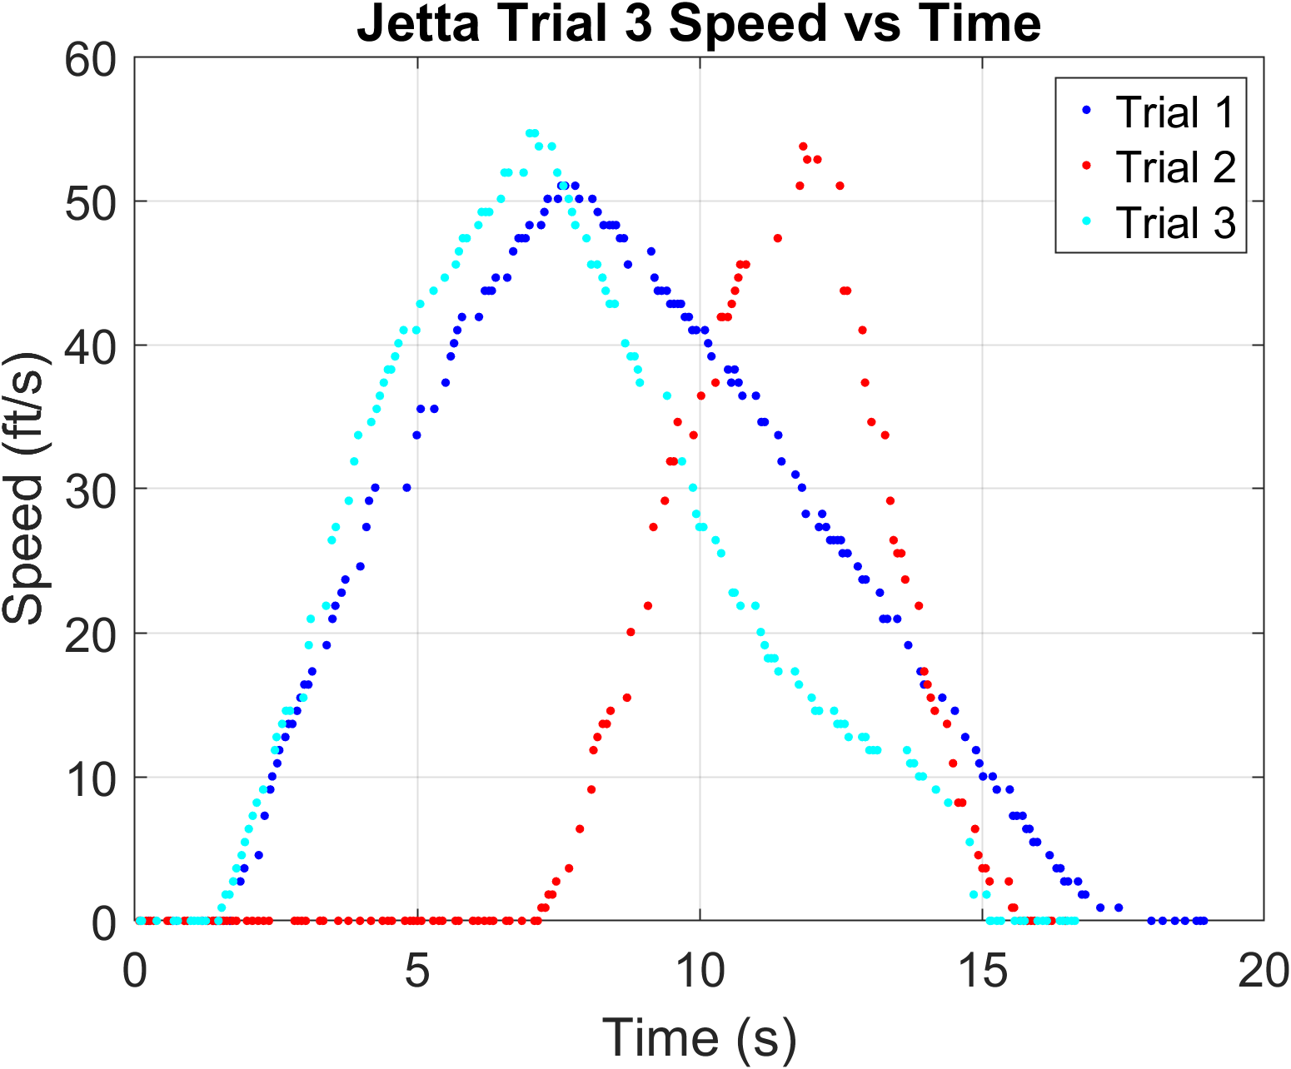
Fig. 1. Jetta speed samples from all three trials. The separate runs show acceleration, braking, and stationary samples.
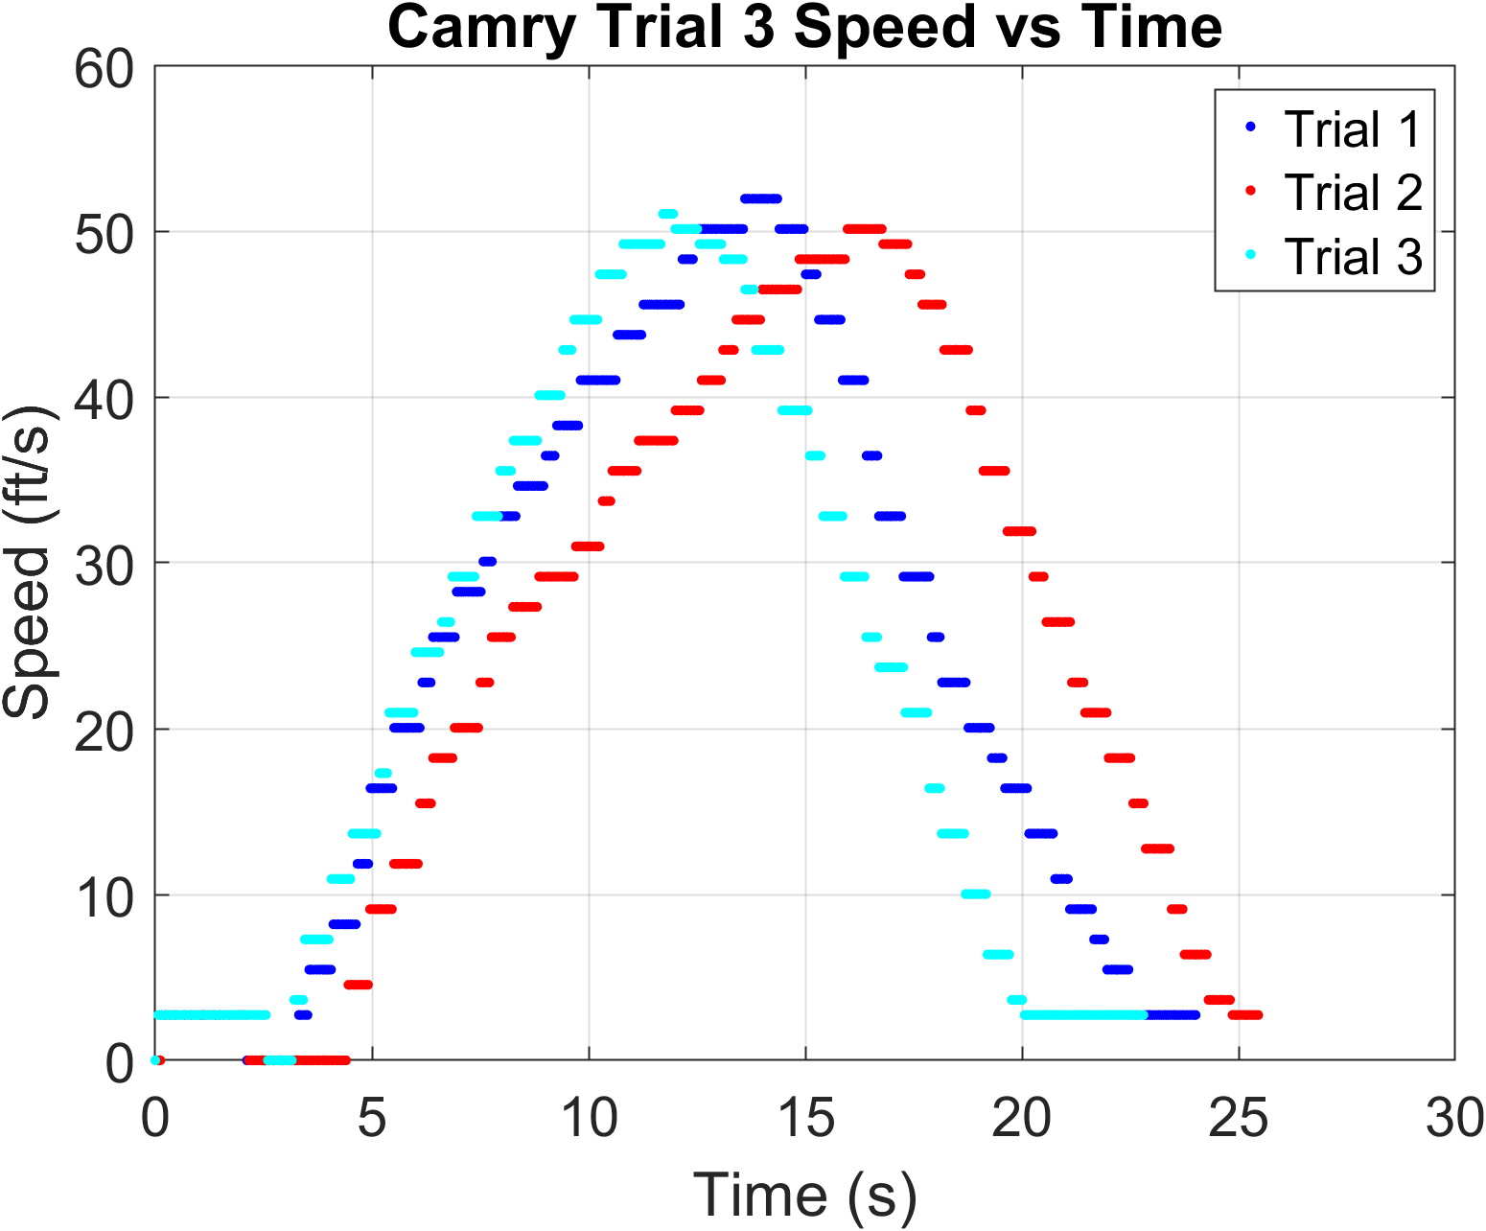
Fig. 2. Camry speed samples from all three trials. The original trial time axes are retained.

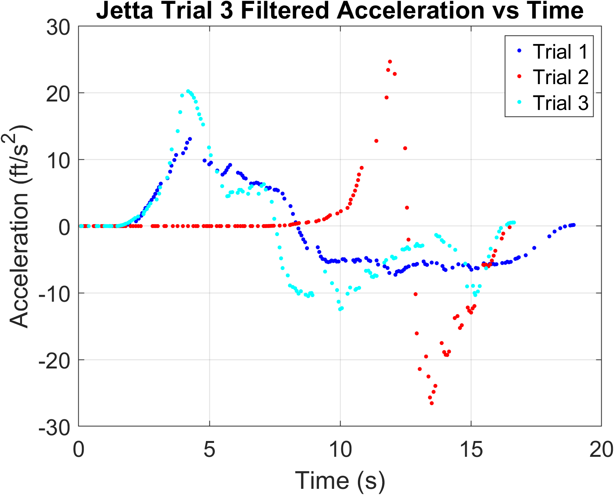
Fig. 3. Jetta filtered acceleration for all three trials. The selected moving intervals supply the linear acceleration fits.
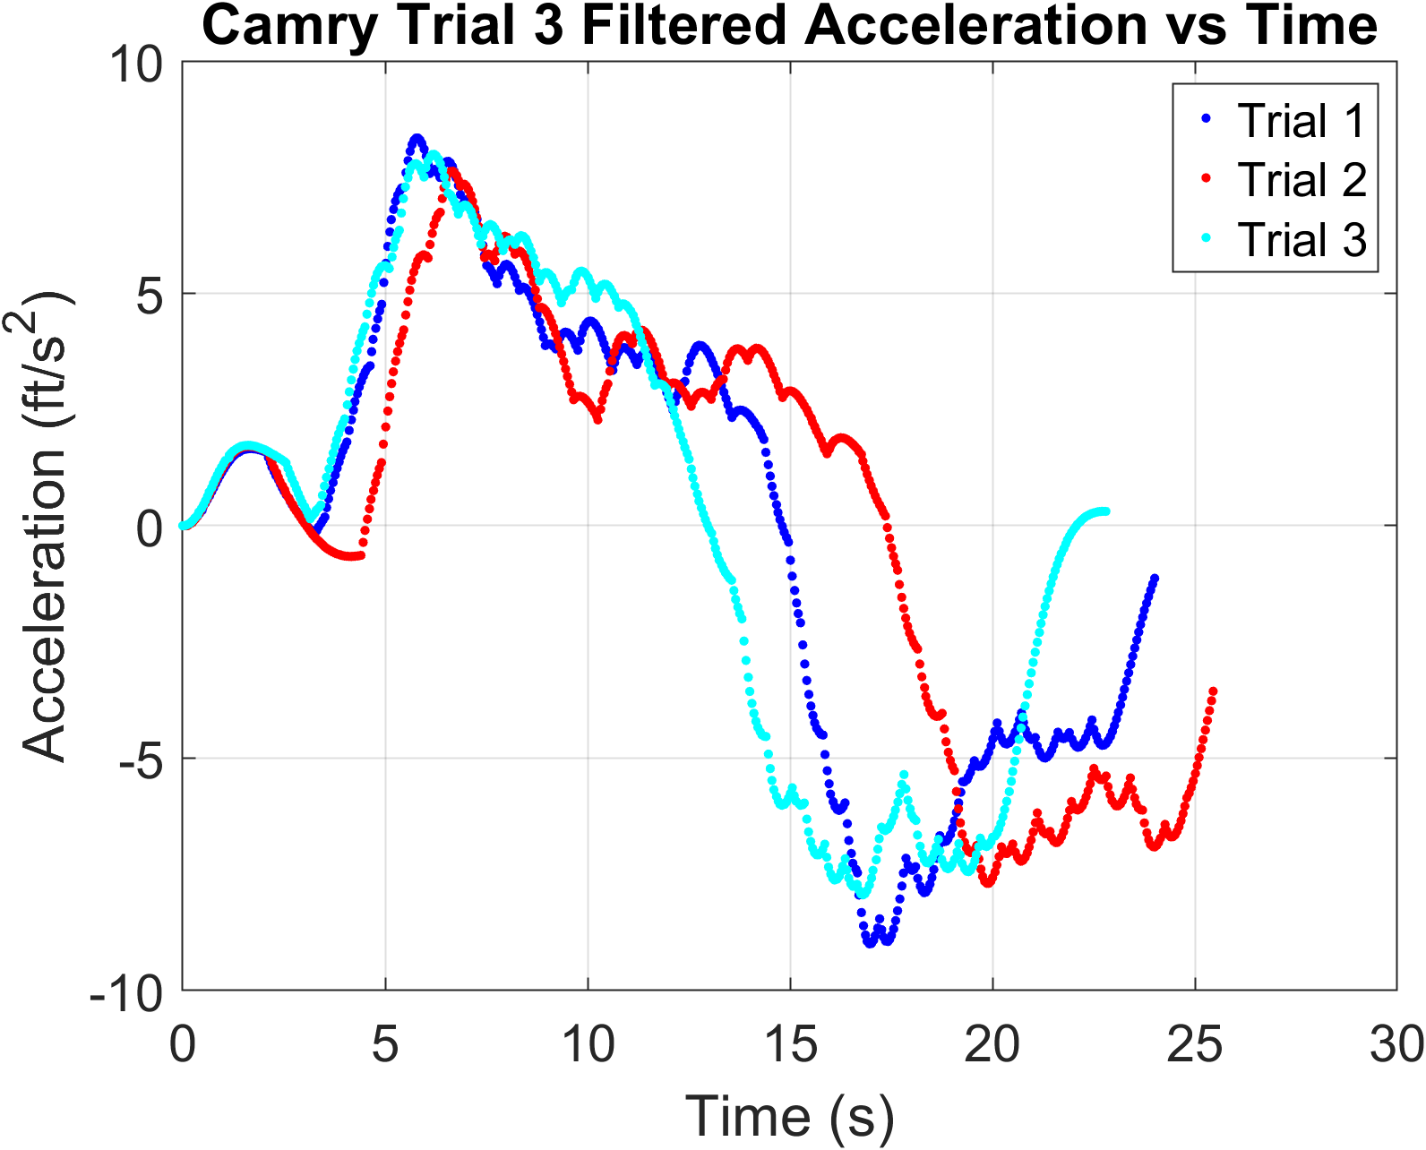
Fig. 4. Camry filtered acceleration for all three trials. These are estimates from the speed-based Kalman filter.

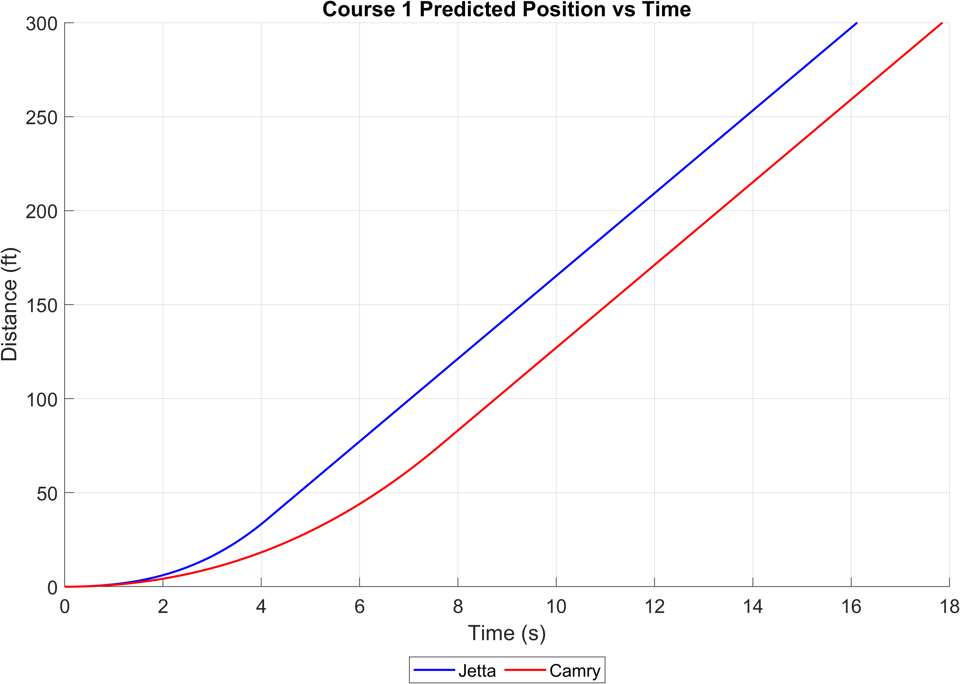
Fig. 5. Course 1 predicted distance. Each vehicle accelerates to 15 mph and cruises to 300 ft; their finish times differ.
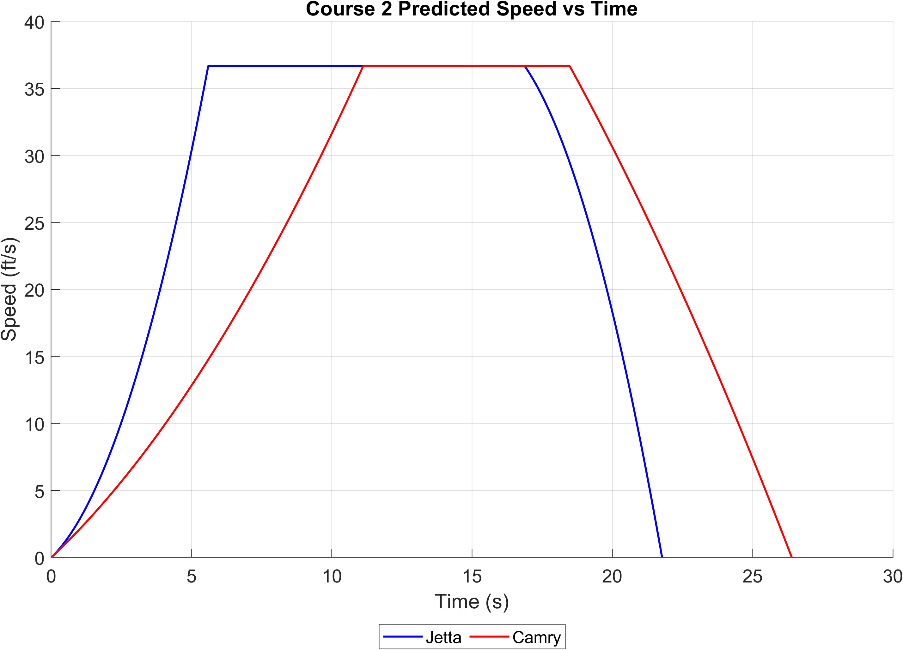
Fig. 6. Course 2 predicted speed. Both vehicles reach 25 mph (36.67 ft/s), cruise, and brake to rest within 600 ft.

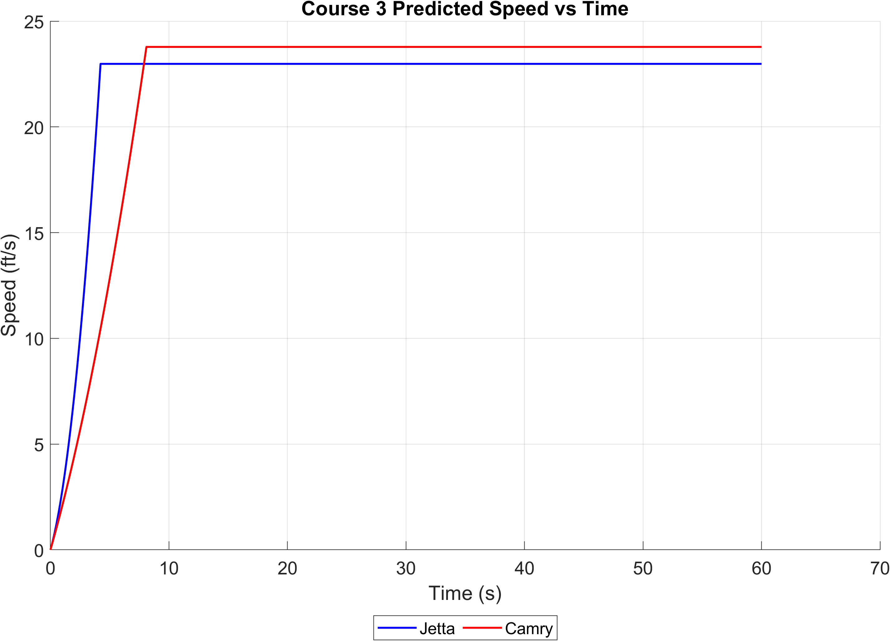
Fig. 7. Course 3 predicted speed. Acceleration and cruise together give a 15 mph average over 1320 ft in 60 s.
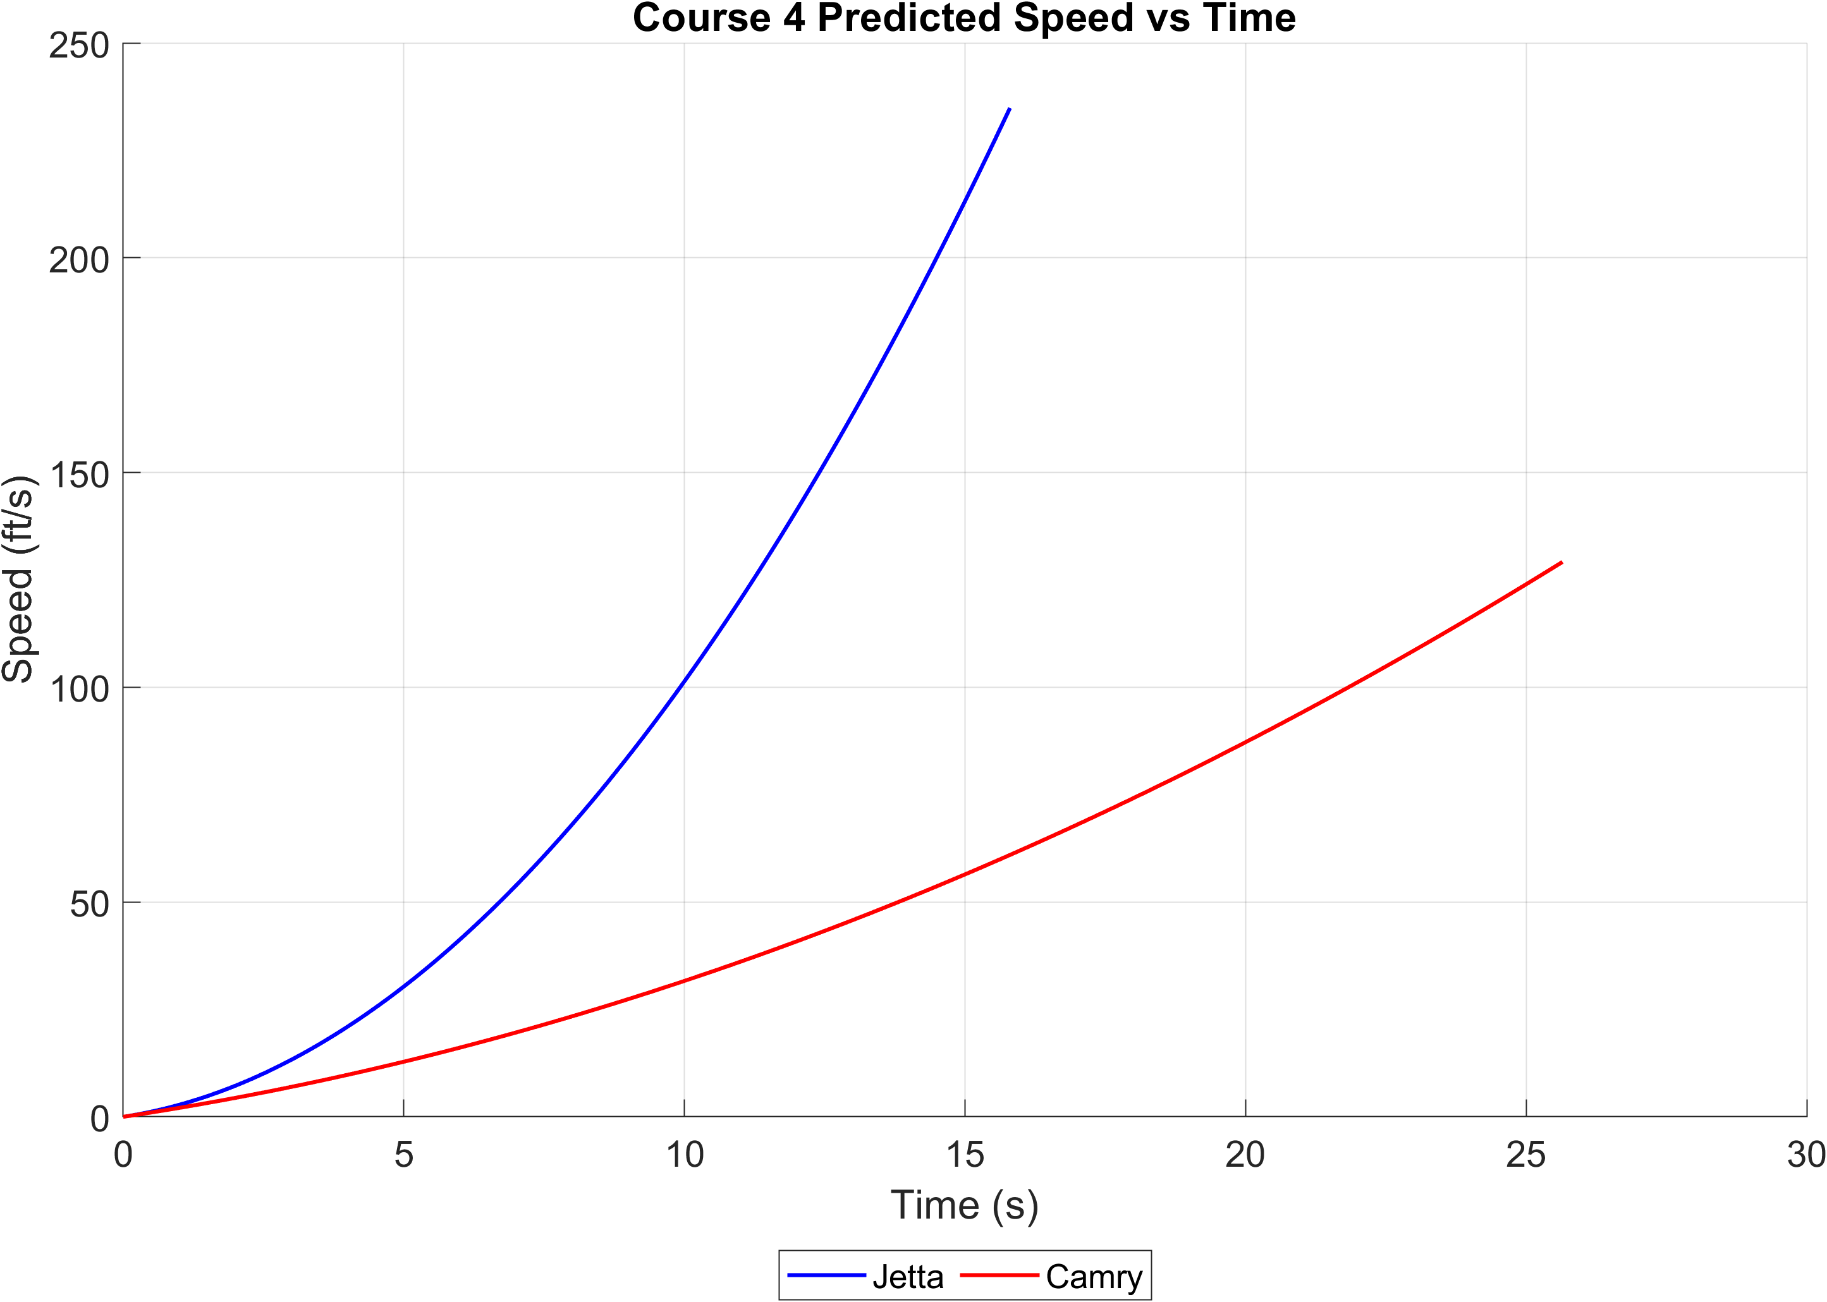
Fig. 8. Course 4 predicted speed using continuous acceleration to 1320 ft. The plotted values follow the unrestricted polynomial model.

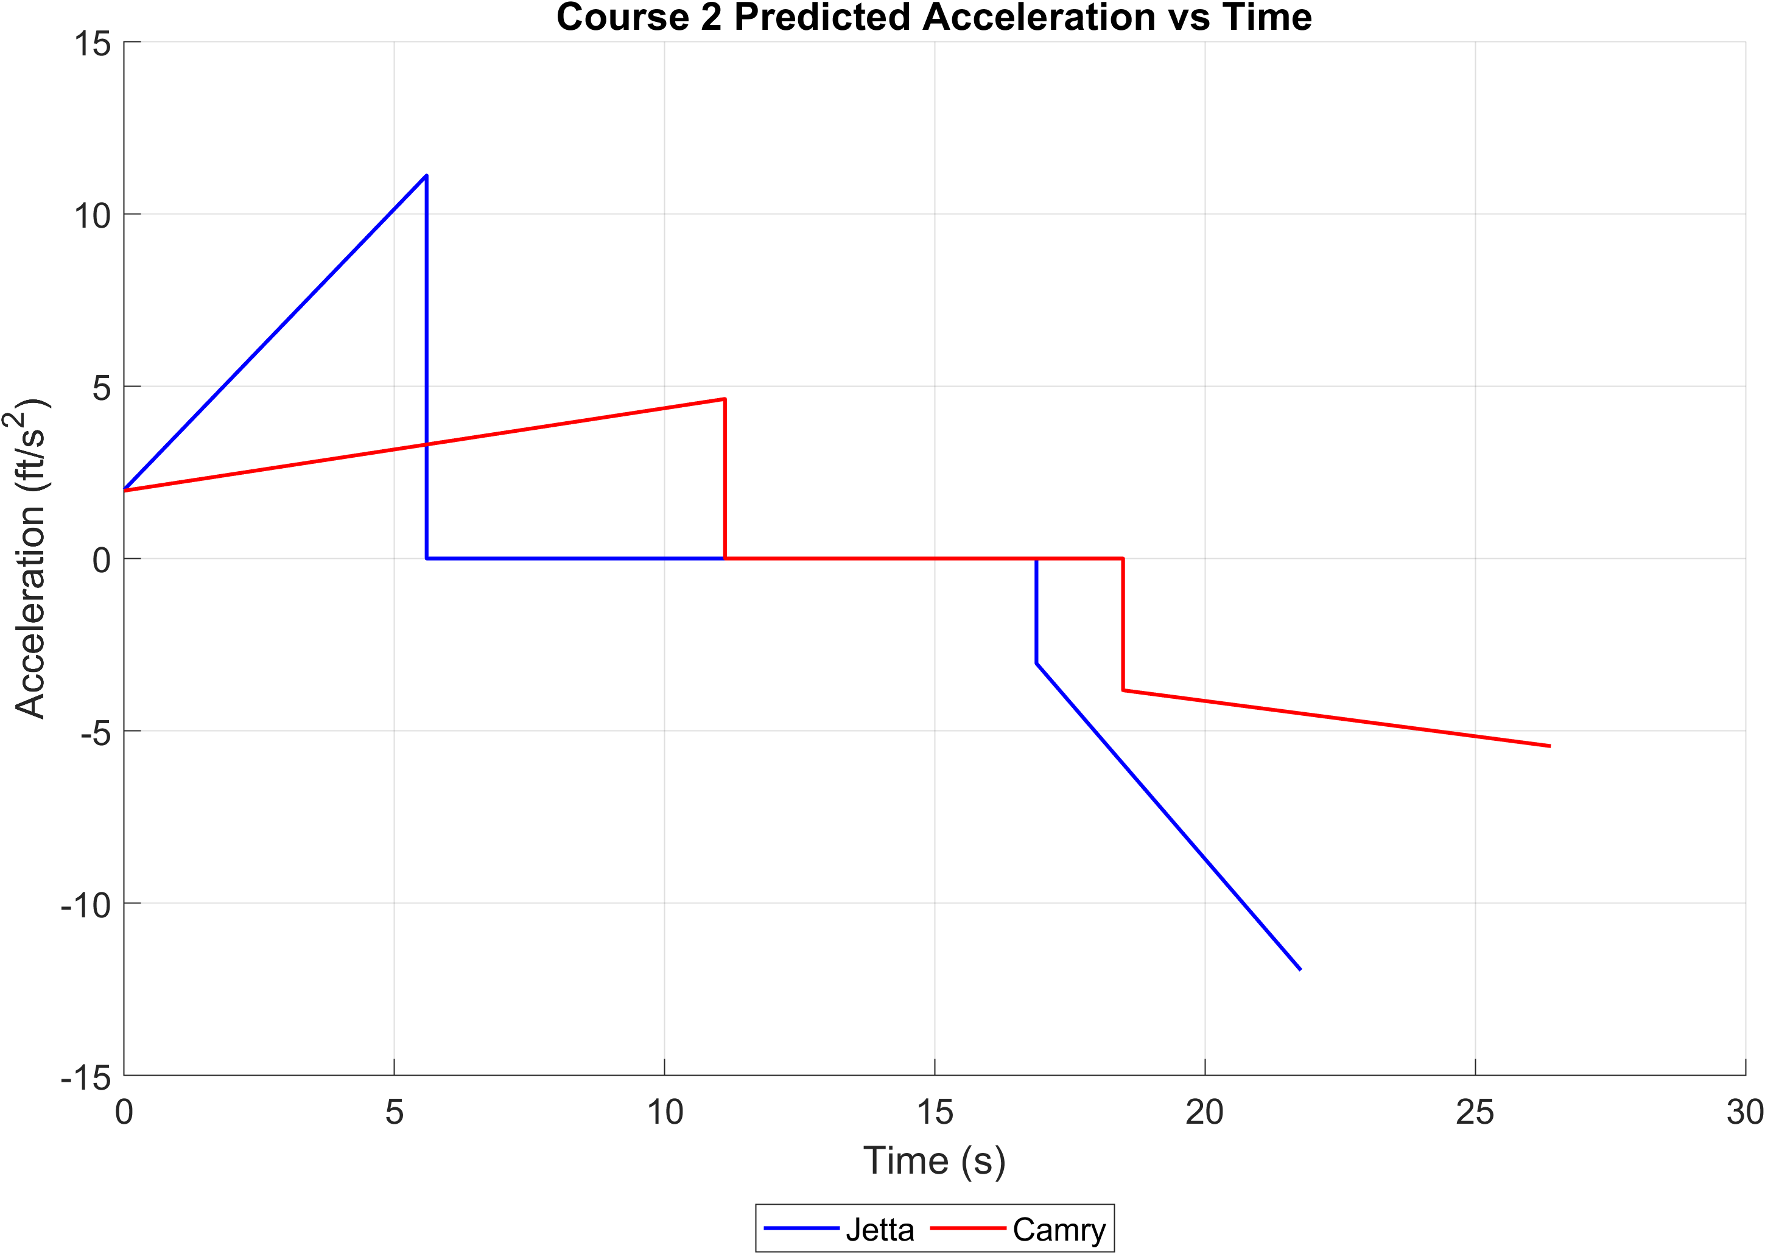
Fig. 9. Course 2 predicted acceleration. Each moving phase has a linear acceleration law; cruise acceleration is zero.
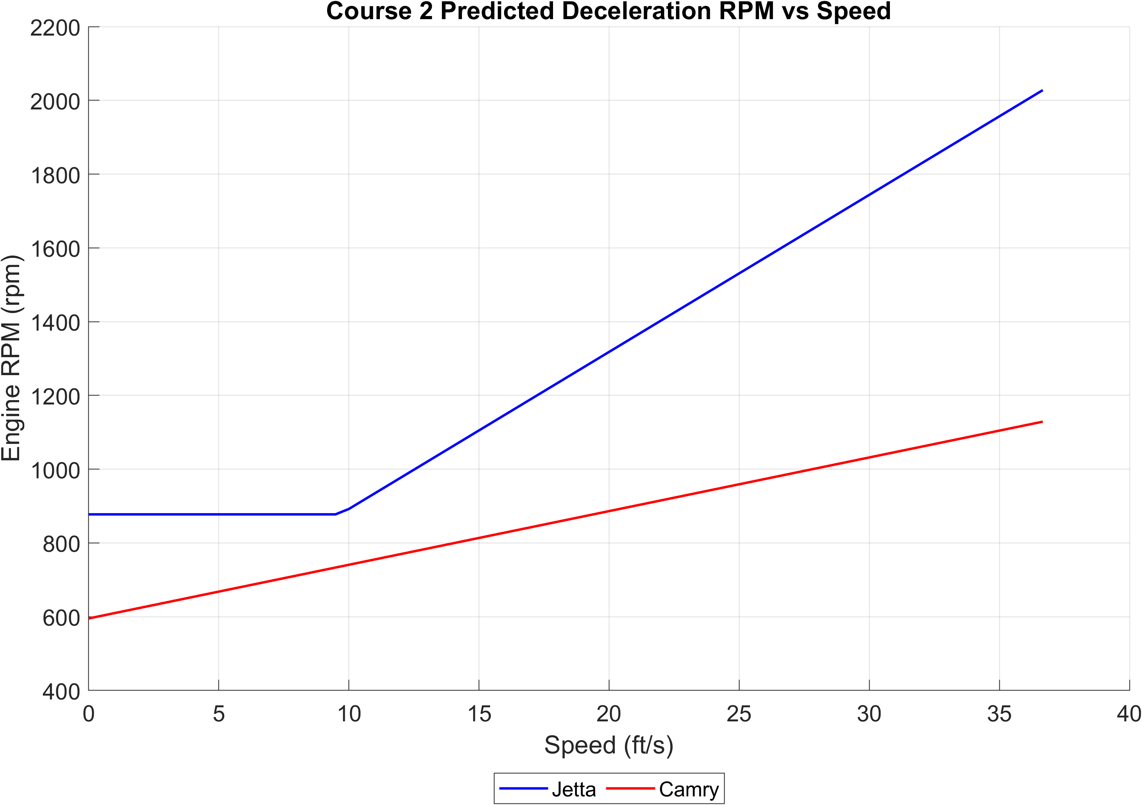
Fig. 10. Course 2 predicted Engine RPM (rpm) versus speed during braking. The phase-specific RPM fit is evaluated along decreasing speed.

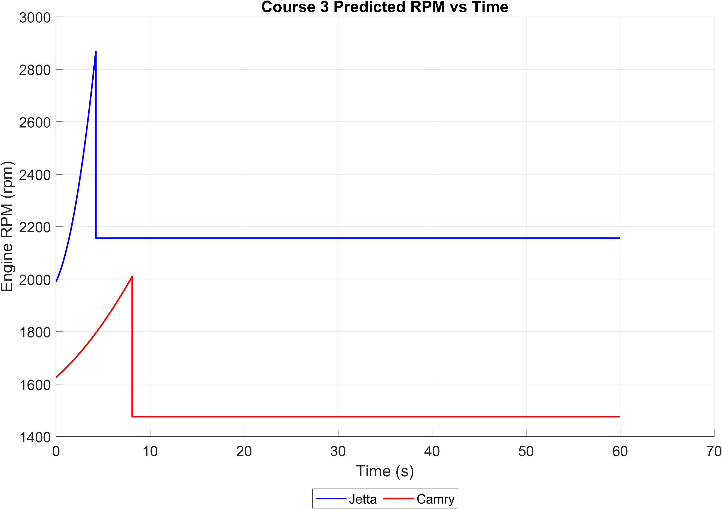
Fig. 11. Course 3 predicted Engine RPM (rpm) versus time. Cruise RPM is the estimated midpoint of the acceleration and braking relationships.
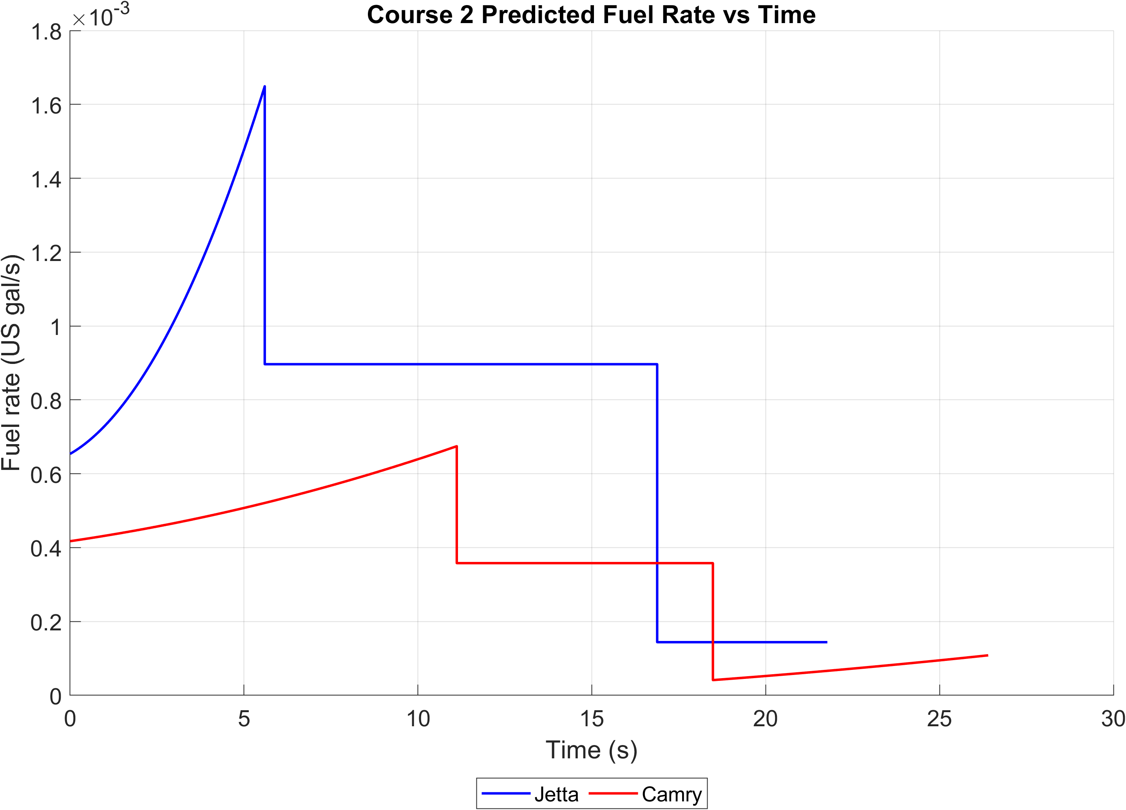
Fig. 12. Course 2 predicted fuel rate. Both curves use US gal/s, including the Camry mass-to-volume conversion.

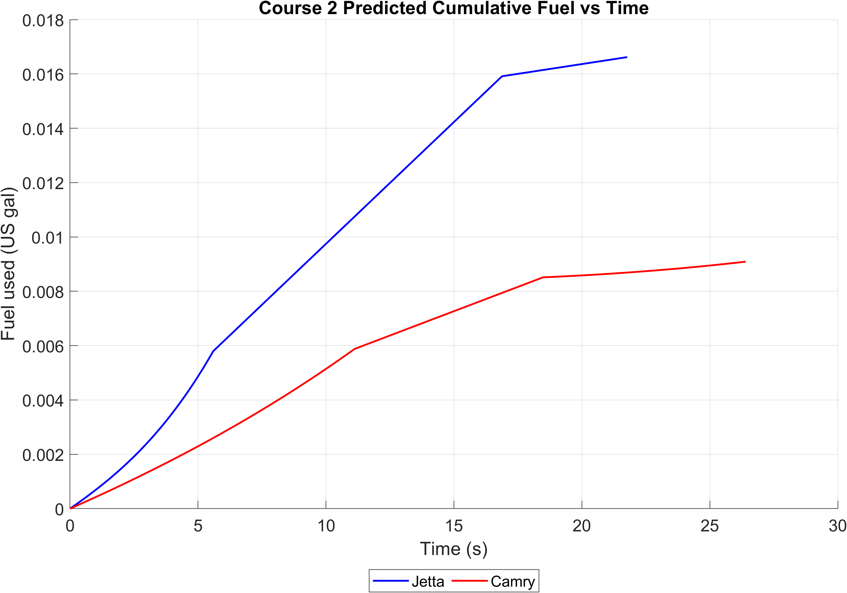
Fig. 13. Course 2 predicted cumulative fuel used, obtained by integrating the corresponding fuel-rate history.
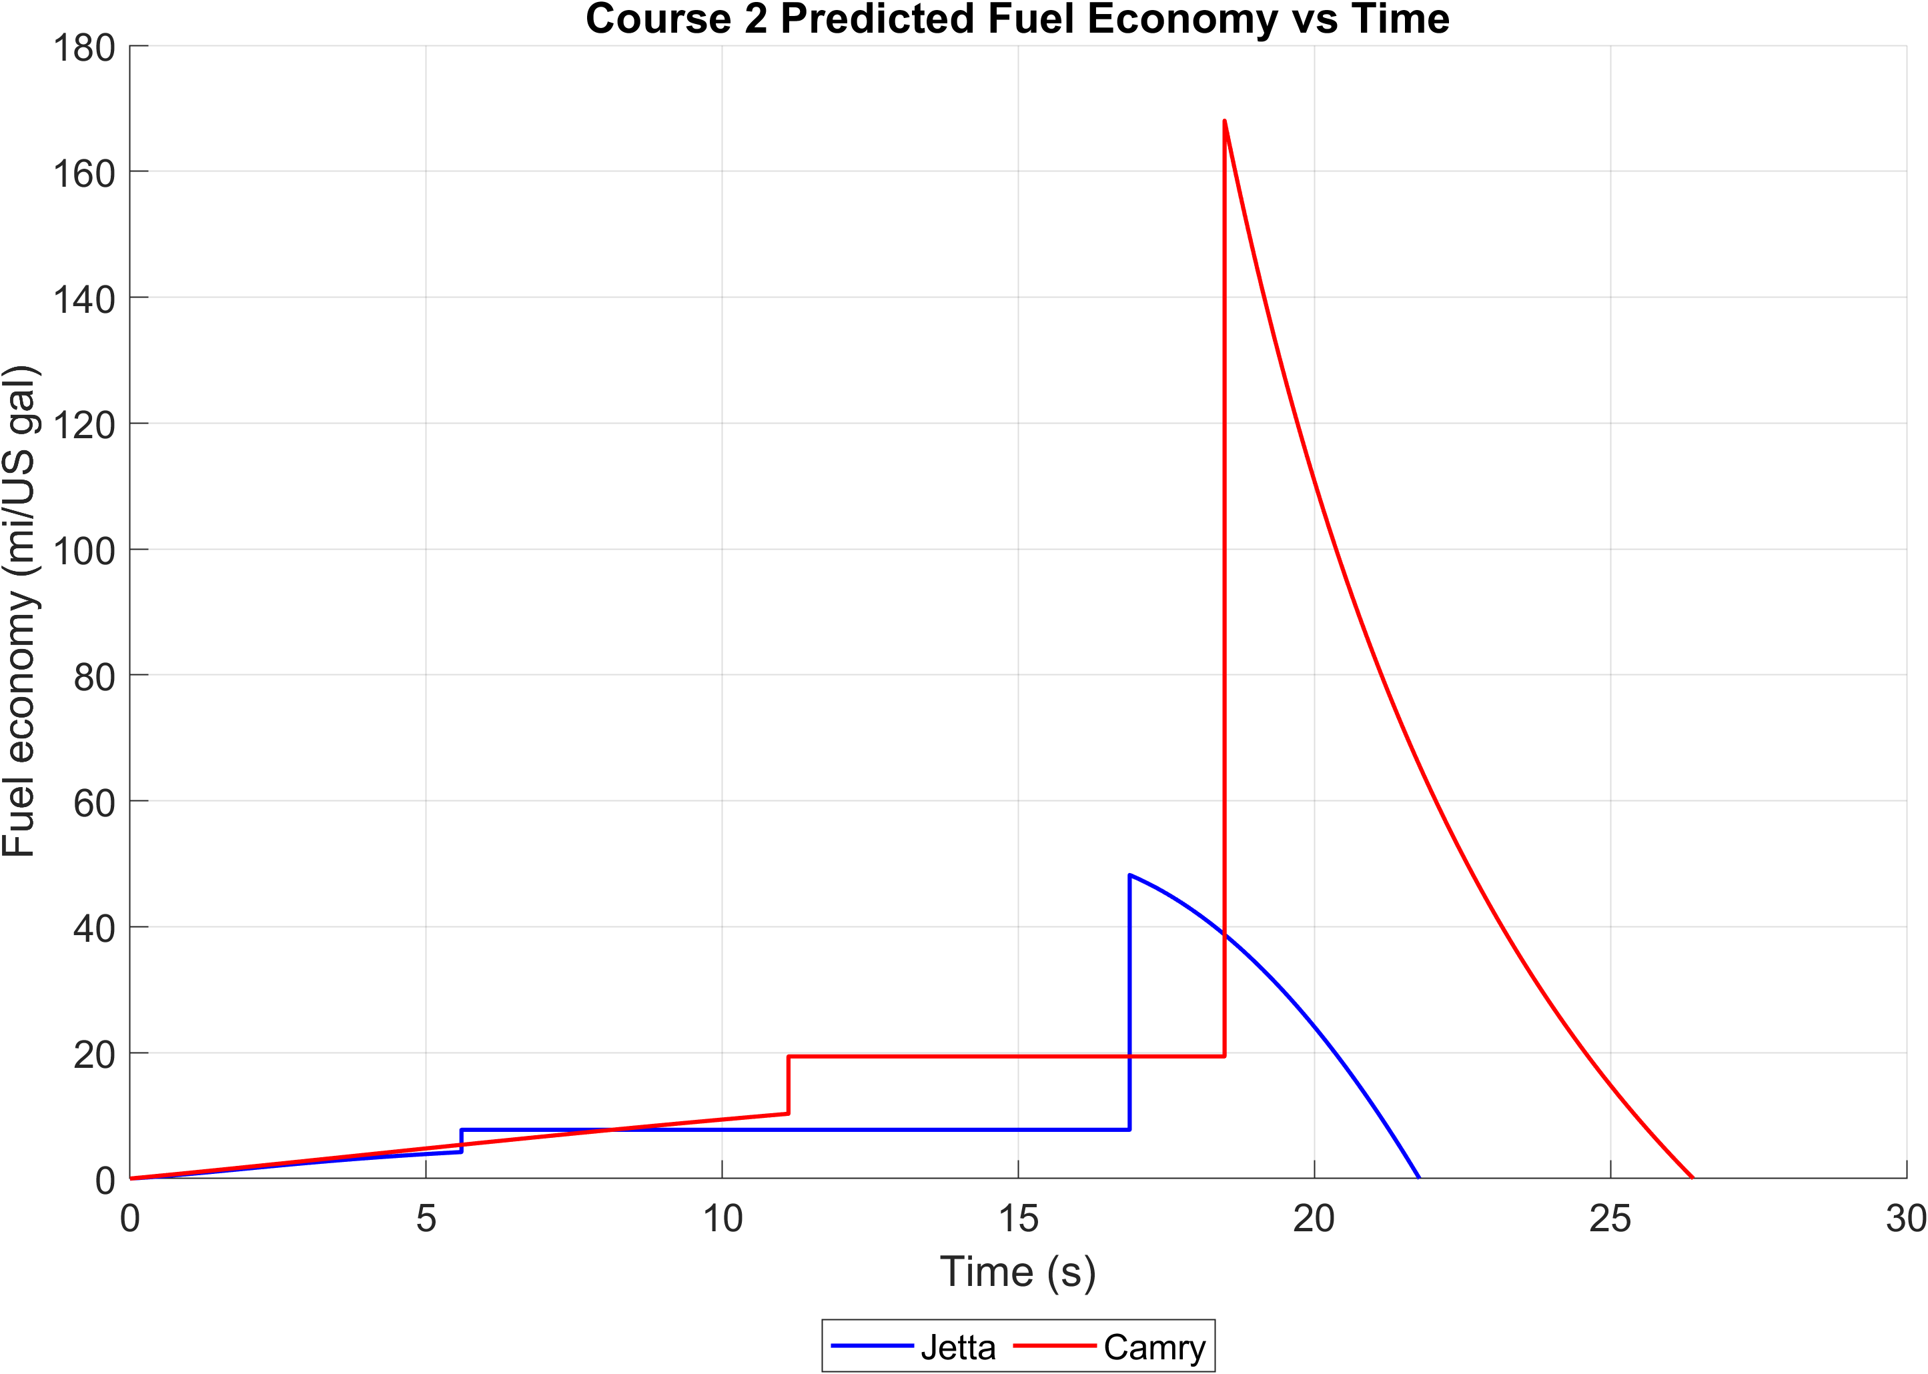
Fig. 14. Course 2 predicted instantaneous fuel economy. MPG is calculated from speed and fuel rate, rather than fitted independently.

